Task Title
Docker-03
Objective
The objective of this task is to watch the Docker-03 video posted on slack and worked on executing the initializing Ansible shown in video.
Prerequisites
List all requirements before starting:
- Dockerfile
- Single stage docker file
- Multi stage docker file
- Docker Image Networks
- Docker save and load
- Docker commits
- Docker scan
Docker compose

Tasks

Task 1- Create an image from running container.
Step by step Implementation
Step 1: To create a new Docker image from an existing running container in order to preserve its current state, configurations, and changes.
Pull NGINX image
docker pull nginx:latest
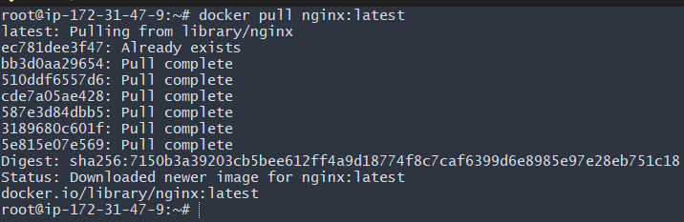

checked that the container is running.
- docker ps
accessed the container terminal.
- docker exec -it nginx-container /bin/bash
Inside the container, you changed the default Nginx page.
- echo "CONTAINER CREATED FROM RUNNING NGINX IMAGE" >> /usr/share/nginx/html/index.html
saved the current state of the container as a new image.
- docker commit nginx-container custom-nginx:v1
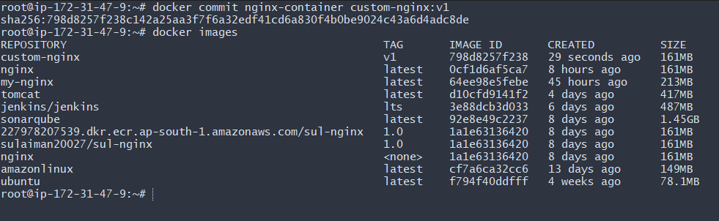
opened the server IP with port 81:
http://<EC2-IP>:81
CONTAINER CREATED FROM RUNNING NGINX IMAGE
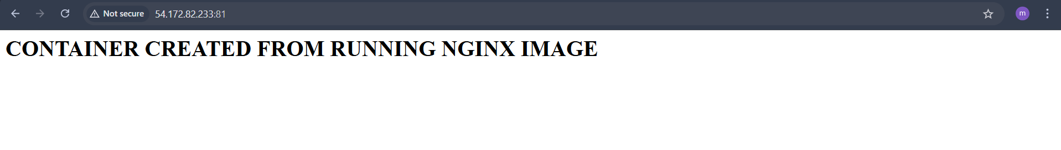
Copy image from local machine to docker server and load the image.
authenticated with Docker Hub.
- docker login
downloaded the latest Nginx image on your local Windows machine.
- docker pull nginx
checked that the image exists locally.
- docker images
exported the image into a .tar file.
- docker save nginx -o nginx.tar
confirmed that nginx.tar was created.
- ls -lh nginx.tar
copied the file from Windows to EC2.
- scp -i linux.pem nginx.tar ec2-user@13.60.210.181:/tmp/

Inside EC2, moved to /tmp and listed files.
cd /tmp
ls
found:
nginx.tar
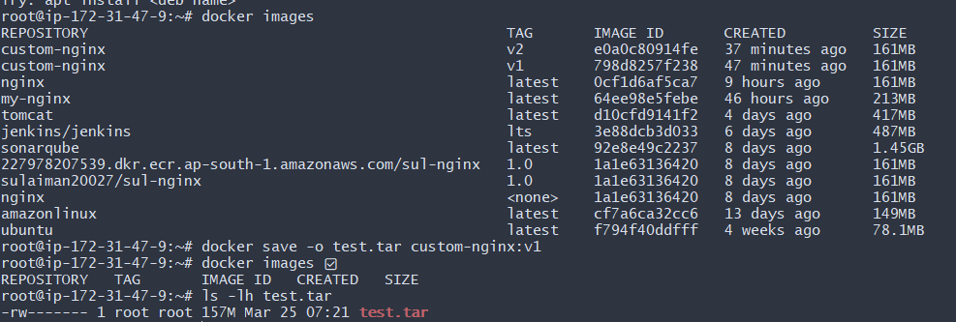

Create Docker image using alpine and customize with tomcat.
created a folder for your Docker build.
- mkdir alpine-tomcat
- cd alpine-tomcat
created and opened a Dockerfile.
- vi Dockerfile
FROM alpine:3.19

# Install Java and required tools
RUN apk add --no-cache openjdk11 wget tar bash

# Set working directory
WORKDIR /opt

# Download and extract Tomcat
RUN wget https://dlcdn.apache.org/tomcat/tomcat-9/v9.0.115/bin/apache-tomcat-9.0.115.tar.gz \
&& tar -xzf apache-tomcat-9.0.115.tar.gz \
&& mv apache-tomcat-9.0.115 tomcat \
&& rm apache-tomcat-9.0.115.tar.gz

# Expose Tomcat port
EXPOSE 8080

# Start Tomcat
CMD ["/opt/tomcat/bin/catalina.sh", "run"]

built the image and named it alpine-tomcat.
- docker build -t alpine-tomcat .
checked available images.
- docker images
saw:
alpine-tomcat latest ~296MB
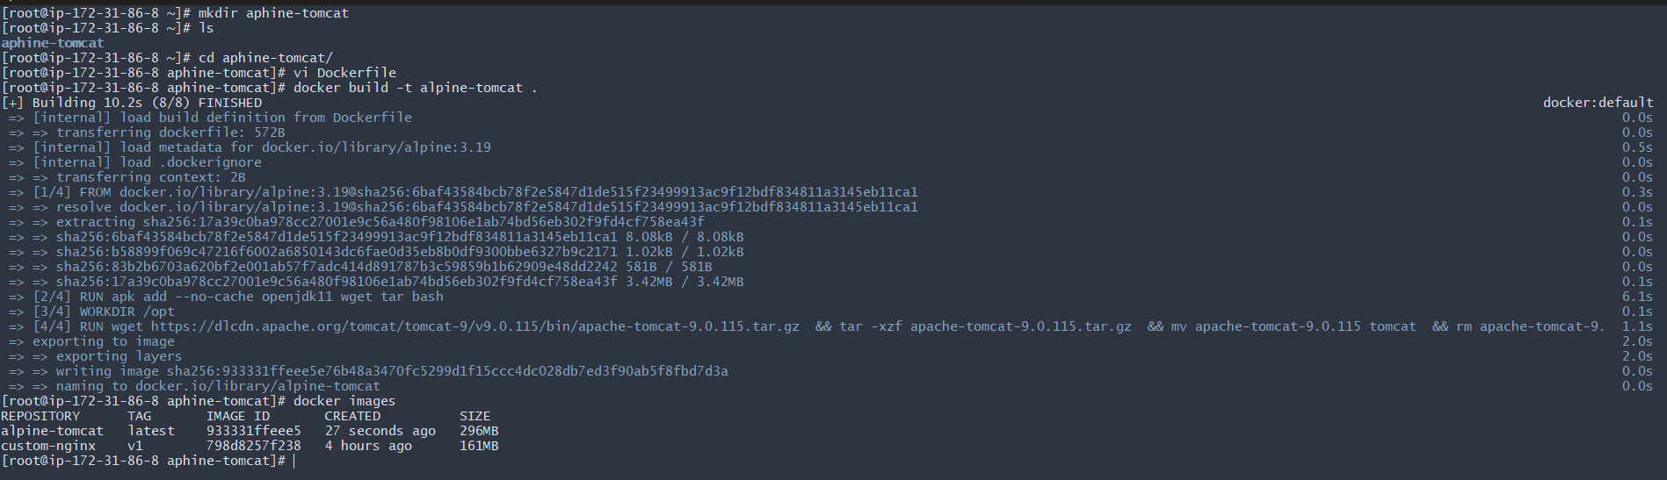

started a container from custom image.
- docker run -d -p 8080:8080 --name tomcat-container alpine-tomcat
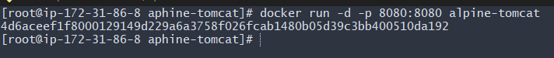
opened:
http://184.72.171.129:8080
And saw the Tomcat welcome page.

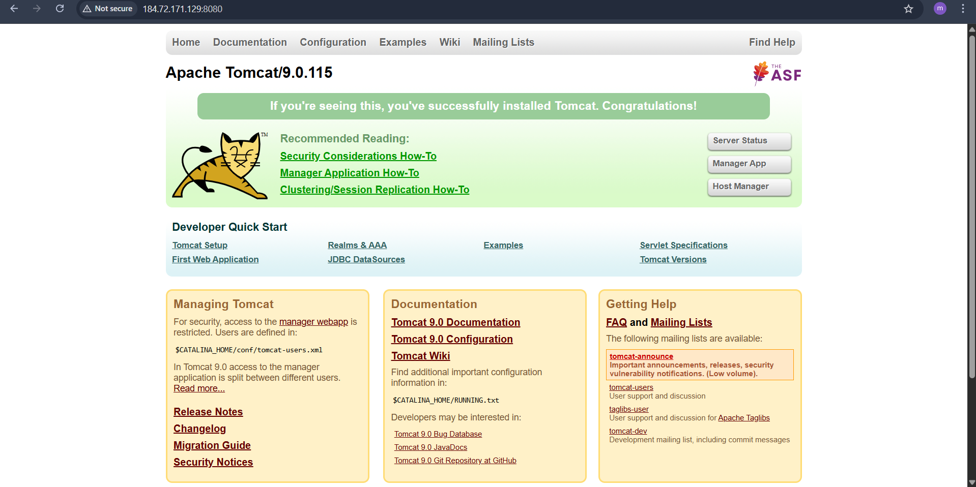
- Create single stage and multi stage docker file using this source code: https://github.com/betawins/multi-stage-example.git
installed Git to download the project source code.
- yum install git -y
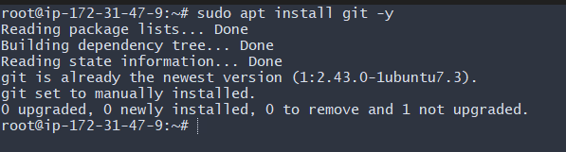
cloned a Maven-based sample project from GitHub.
- git clone https://github.com/betaws/multi-stage-example.git
moved into the cloned folder.
- cd multi-stage-example
Then checked files:
ls
opened and verified the Dockerfile.
- vi Dockerfile
FROM maven:3.9.6-eclipse-temurin-8

WORKDIR /app

COPY . .

RUN mvn clean package -DskipTests

EXPOSE 8080
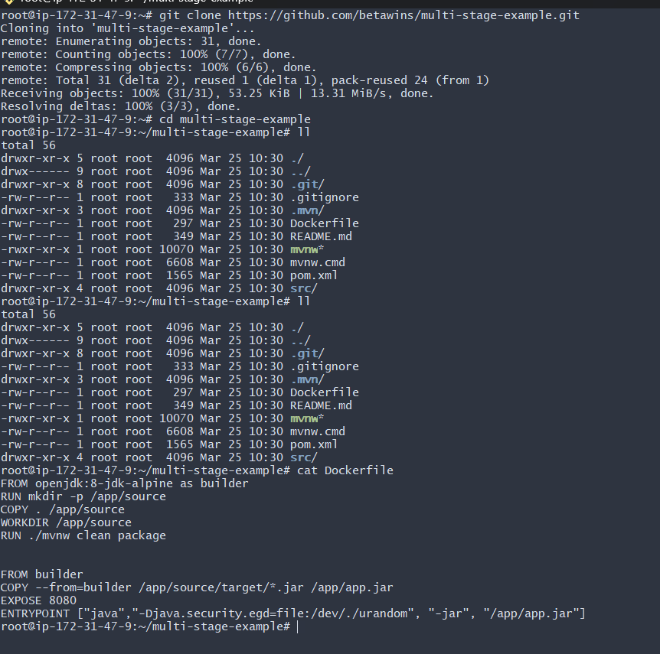
built the Docker image and named it maven-app.
- docker build -t maven-app .
started a container and mapped port 8081 → 8080.
- docker run -d -p 8081:8080 --name myapp maven-app

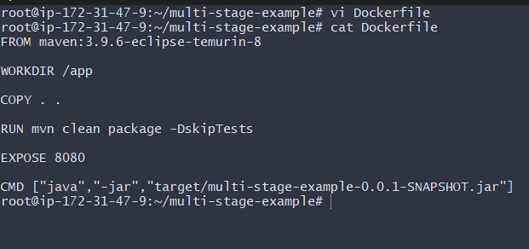
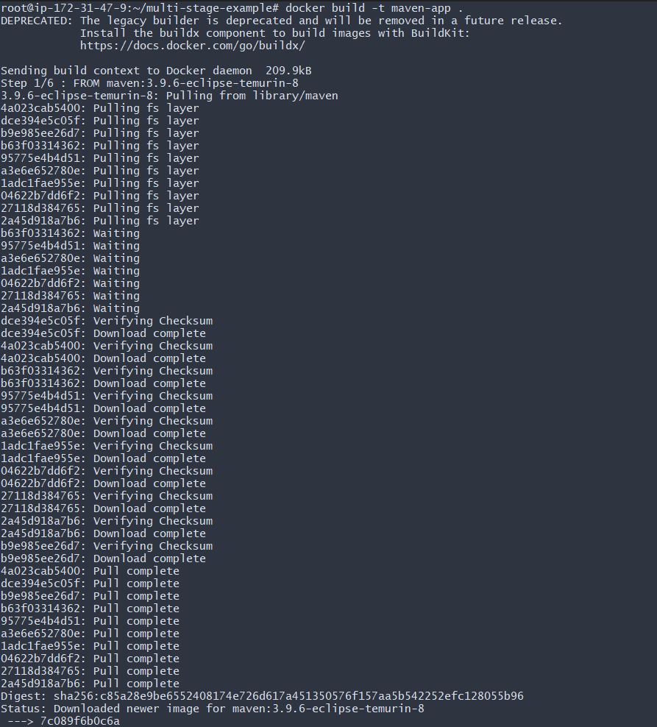
opened:
http://54.172.82.233:8081
And saw:

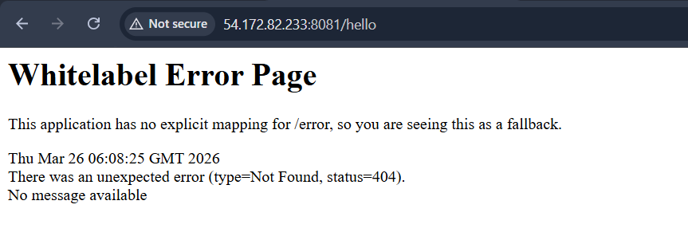
Install docker compose and execute sample application.
downloaded Docker Compose on your EC2 server.
- sudo curl -L https://github.com/docker/compose/releases/latest/download/docker-compose-linux-x86_64 \
-o /usr/local/bin/docker-compose
made the file executable.
- sudo chmod +x /usr/local/bin/docker-compose
created a shortcut link.
- sudo ln -s /usr/local/bin/docker-compose /usr/bin/docker-compose
opened:
http://54.172.82.233:8090
And saw the Welcome to nginx page.

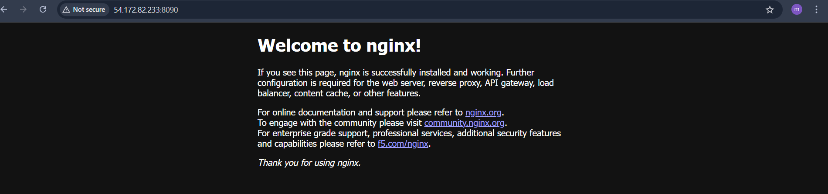
- Implement solution to scan images when pushed to docker registry.
On Docker Hub (repository settings):
- Open your repository: sulaiman20027/sul-nginx
- Go to Settings
- Under Image security insight settings
- Select Docker Scout image analysis
- Click Save
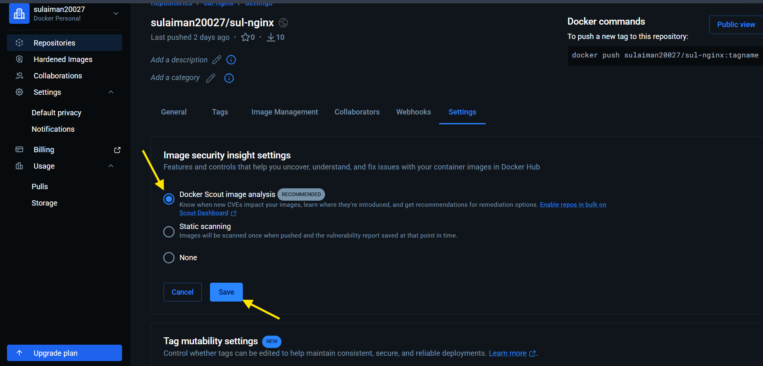
authenticated from your EC2 server.
- docker login

listed all available images.
- docker images
renamed (tagged) your local image to match your Docker Hub repo.
- docker tag multi-stage-app:latest sulaiman20027/sul-nginx
- uploaded the image.
- docker push sulaiman20027/sul-nginx

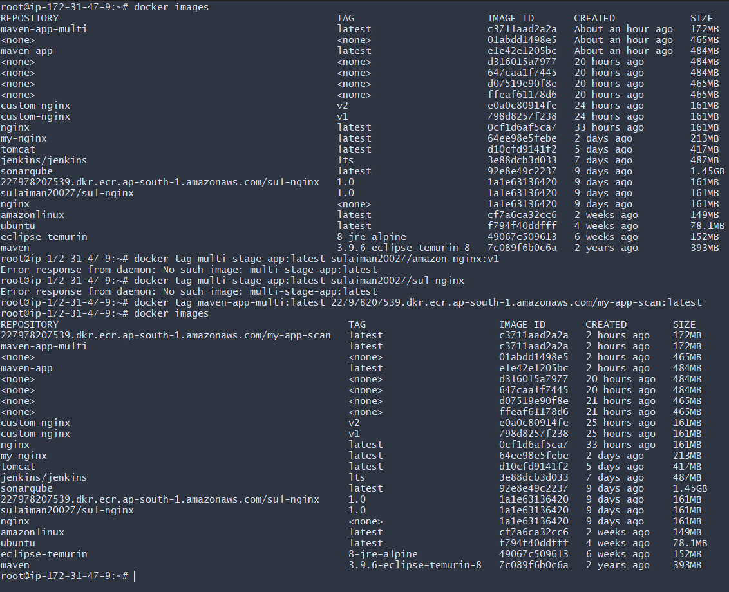
On Docker Hub → Tags section:
saw:
v1
And vulnerability scan results.
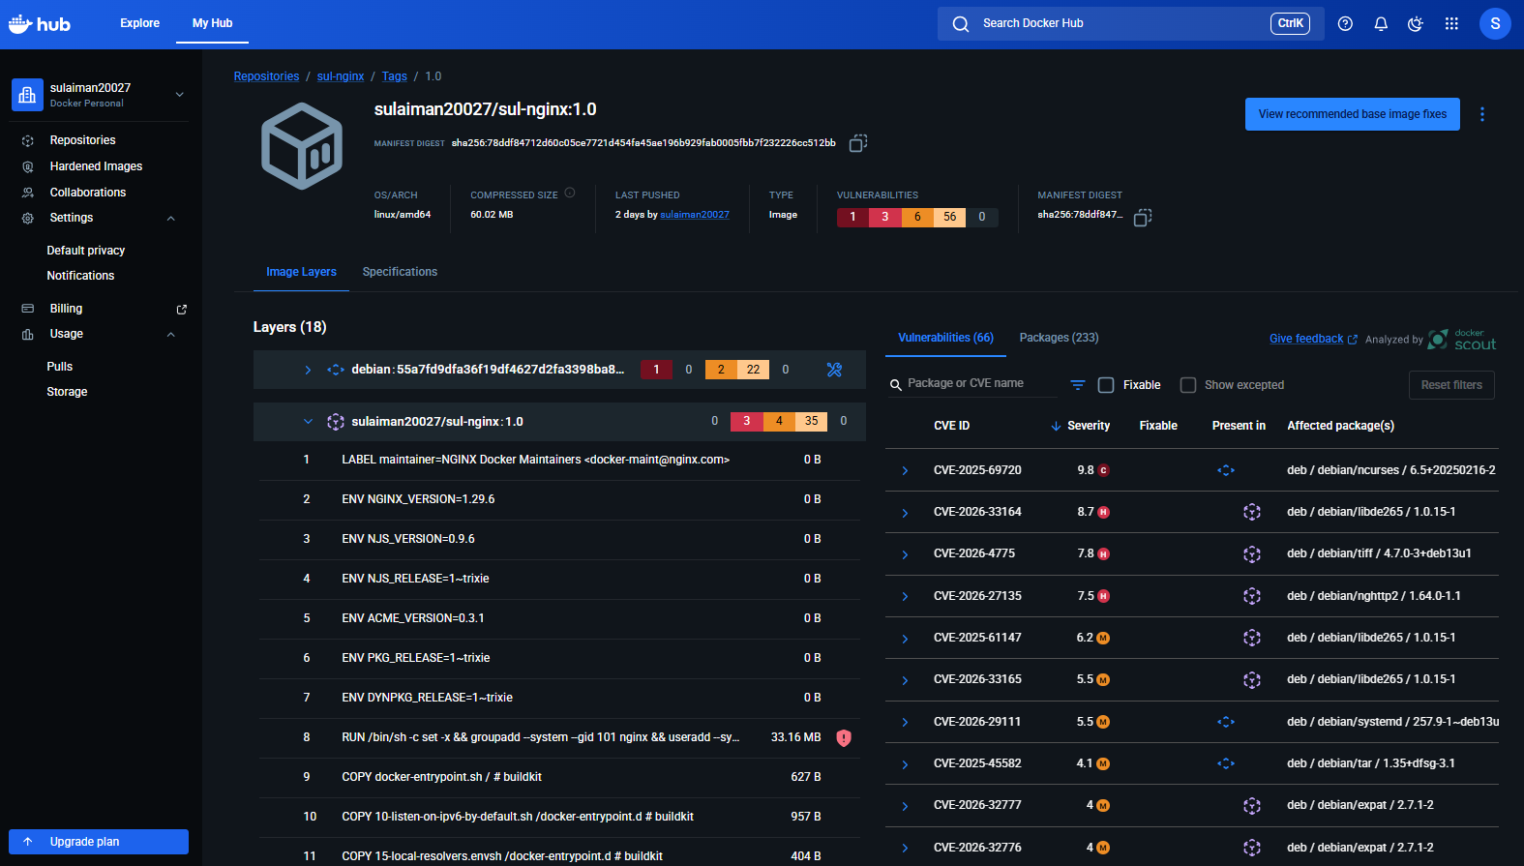
- Implement solution to scan images when pushed to AWS ECR.

authenticated Docker with AWS ECR using AWS CLI.
- aws ecr get-login-password --region eu-north-1 \
| docker login --username AWS --password-stdin 885581373585.dkr.ecr.eu-north-1.amazonaws.com
verified available images.
- docker images
tagged your local image with the ECR repository URI.
- docker tag multi-stage-app:latest \
885581373585.dkr.ecr.eu-north-1.amazonaws.com/amazon-nginx:v1

uploaded the image to AWS ECR.
- docker push 885581373585.dkr.ecr.eu-north-1.amazonaws.com/amazon-nginx:v
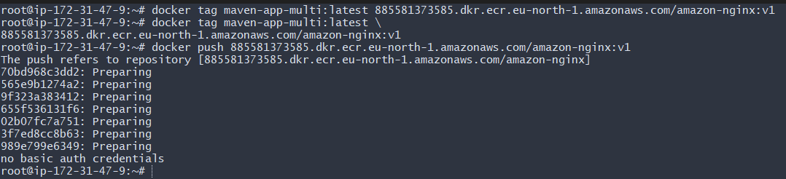
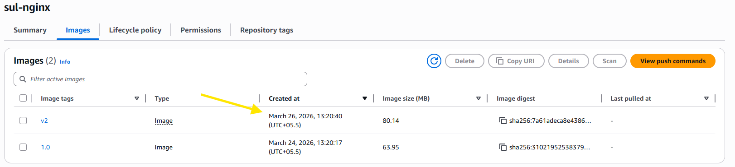
opened the image details and viewed:
Scanning and vulnerabilities → Complete
Critical: 0
High: 1
Medium: 6
Low: 0

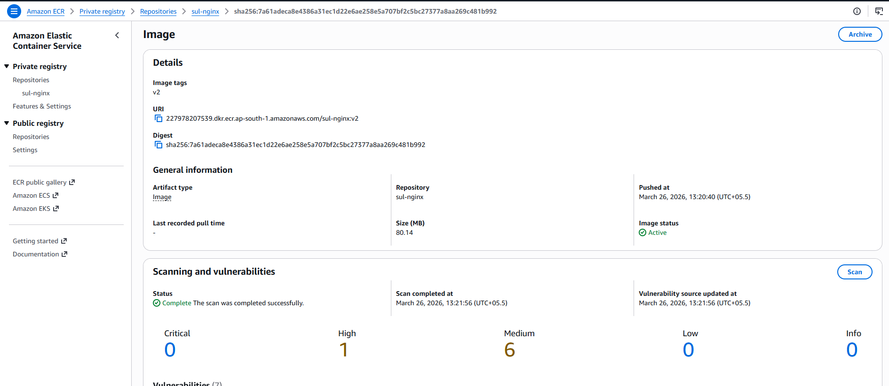
- Create a Jenkins pipeline to create a docker image and push the image to Docker hub.
In Jenkins UI:
- Go to:
- Manage Jenkins → Credentials → System → Global credentials → Add Credentials
- Select:
  - Kind: Username with password
  - Username: sulaiman20027
  - Password: (Docker Hub password / token)
  - ID: Docker
  - Description: Docker
- Click Create
This is used for Docker Hub login in pipelines
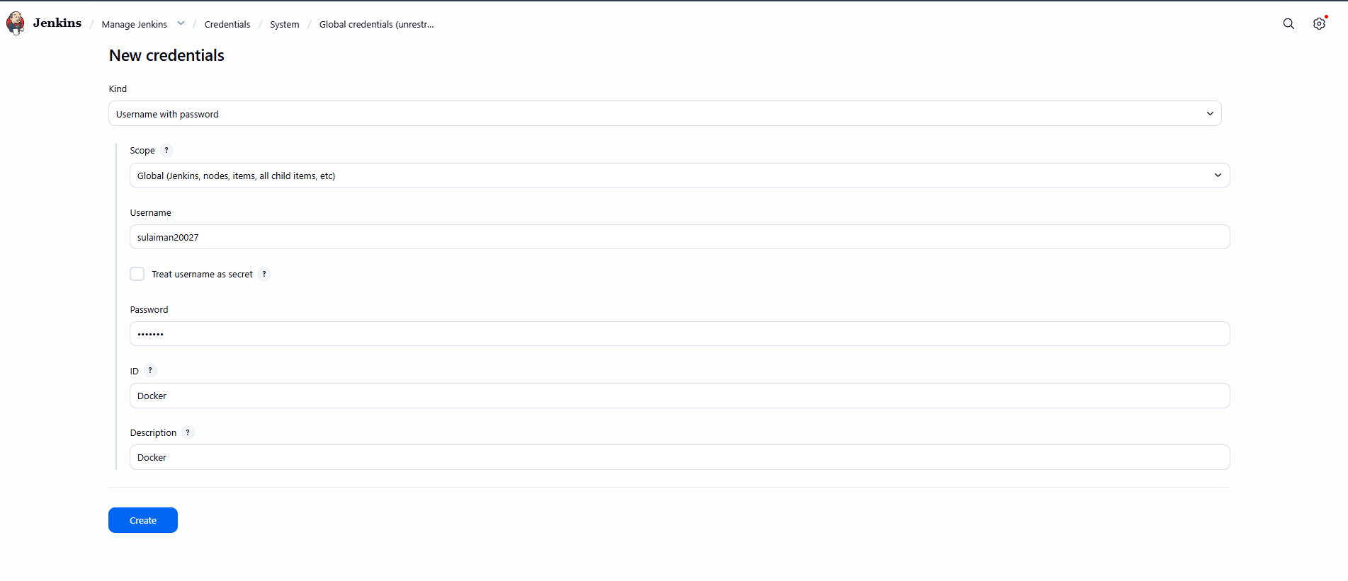
In Jenkins:
Manage Jenkins → Plugins → Available plugins → Search "Docker"
You installed:
✔ Docker
✔ Docker Commons
✔ Docker Pipeline
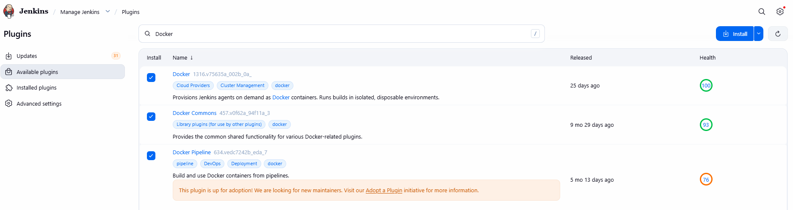
On Jenkins EC2 instance:
- yum install docker -y
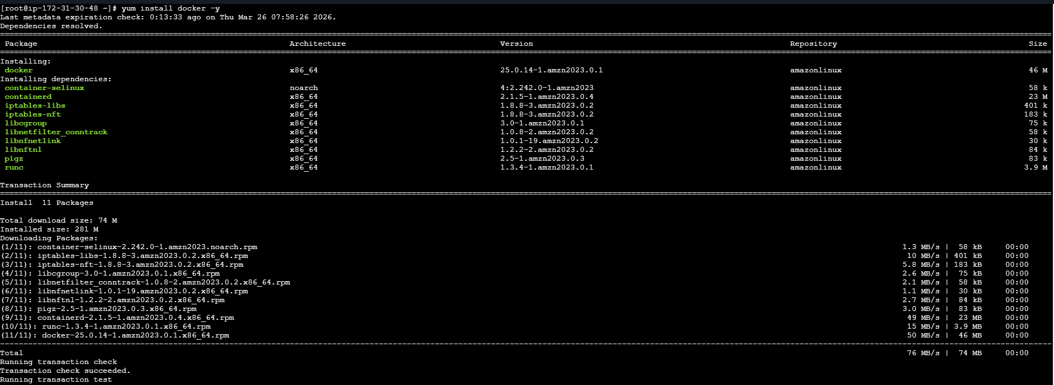
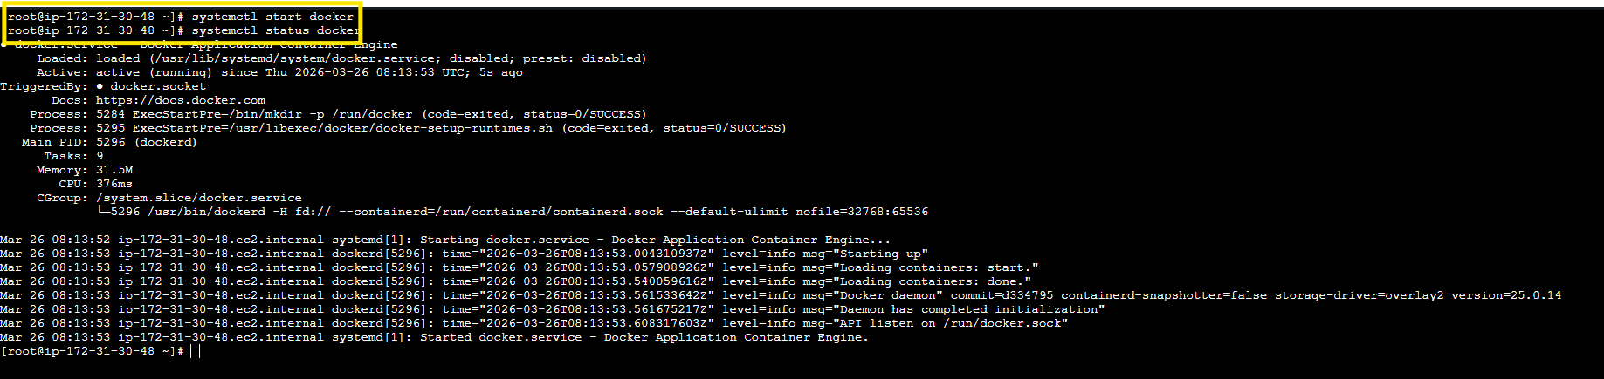
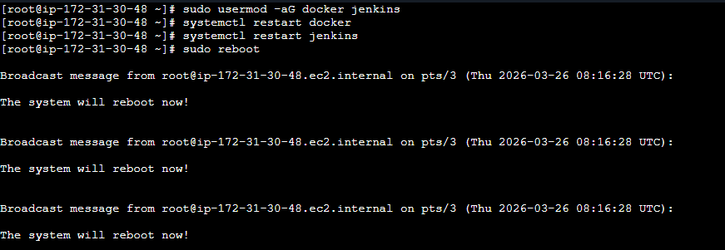
In Jenkins UI:
- Click New Item
- Enter name: Docker
- Select: Pipeline
- Click OK
